Syracuse University Student Is Making Miracles Happen
By Mya Pfeifer
SYRACUSE, N.Y., Sept. 18, 2019 -- According to the American Childhood Cancer Organization, cancer is the top cause of death for children in the United States. When Syracuse University senior Molly Coletta lost her friend to pediatric cancer, she turned grief into motivation to live a life that honored her friend. She is now dedicating a large majority of her time to supporting Children’s Miracle Network Hospitals through her involvement with OttoTHON (Syracuse University’s Dance Marathon), as well as through her internship with Boston Children’s Hospital this past summer. Everything she does is driven by the desire to make miracles in the lives of kids just like her best friend.
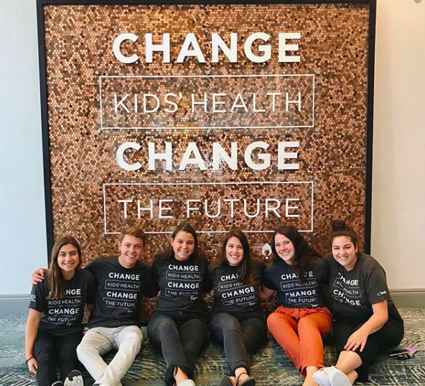
Coletta is from Norfolk, Massachusetts, and she is currently a senior at Syracuse University majoring in art photography. At the age of 8, Coletta’s best friend Maddie was diagnosed with a rare form of pediatric cancer that affected her bones. Two years later, at the age of 10, Maddie lost her battle with cancer and passed away. Since then, Coletta has strived to live her life the way she believes her best friend would have wanted her to.
Molly Coletta (third from the right) along with five other members of the OttoTHON executive board at the Dance Marathon Leadership Conference in July 2019, in St. Louis, Missouri. Photo courtesy of Molly Coletta.
One example of how Coletta has been living her life in honor of Maddie is through her involvement with OttoTHON. OttoTHON is Syracuse University’s annual dance marathon which raises money to support the Upstate Golisano Children’s Hospital, which is the local Children’s Miracle Network Hospital in Syracuse, New York.
Prior to her involvement in OttoTHON, Coletta had some familiarity with Children’s Miracle Network Hospitals. Maddie had received treatment at Boston Children’s Hospital, which is within the Children’s Miracle Network. Coletta took part in OttoTHON for the first time during her sophomore year and has since individually raised over $5,000 for the Upstate Golisano Children’s Hospital.
Coletta’s friends encouraged her to take part in OttoTHON, which motivated her to register for the event in order to dance in honor of Maddie. She got more involved with the organization by joining the fundraising committee that same year. After attending her first OttoTHON event, she was inspired to be more involved in the organization. After discovering her passion for the organization, Coletta knew she wanted to take on a larger role on the executive board.
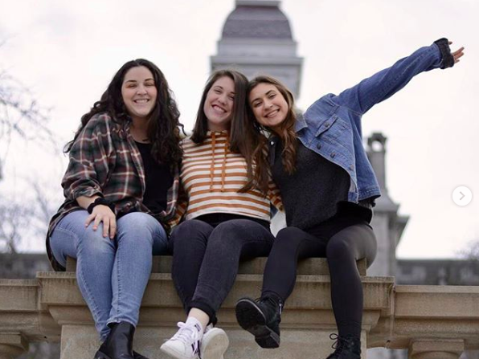
Two years later, Coletta now holds the position of executive director for the 2019 OttoTHON team. While this position comes with many responsibilities, Coletta never slows down in her pursuit to fundraise and advocate for Children’s Miracle Network Hospitals. Coletta said “I always have my best friend in the back on my mind,” which helps her to remember why she does what she does.
Coletta (middle) with Brooke Tanner (left), OttoTHON External Director, and Julia Gregoire (right), OttoTHON internal director. Photo courtesy of Molly Coletta.
Her passion for OttoTHON and Children’s Miracle Network Hospitals is clear to those around her, including OttoTHON’s internal director Julia Gregoire who said, “Her passion for this organization is beyond measurable and it shines through in everything she does.”
Because of OttoTHON, Coletta has developed a deeper passion for Children’s Miracle Network and children’s health in general. She was able to explore her passion for Children’s Miracle Network over the past summer when she had the opportunity to intern with the Children’s Miracle Network Team at Boston Children’s Hospital. In this position, Coletta had the chance to see what Children’s Miracle Network does on a corporate level beyond the dance marathon movement, and she said the experience helped her “really understand how huge its [Children’s Miracle Network] impact is across the country.”
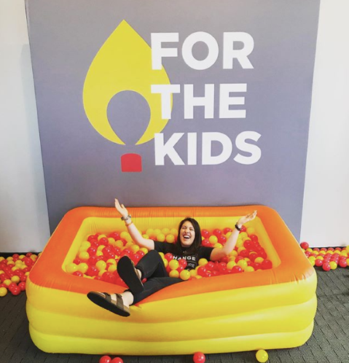
A token of dance marathons is to remember “the why” of it all, meaning to reflect on why everyone is there. Gregoire discussed that Coletta’s “why” is, first and foremost, the kids at Upstate Golisano Children’s Hospital and their families. She said, “With everything that she does, the kids at Upstate are at the forefront of her mind.”
Coletta at the Dance Marathon Leadership Conference in July 2019. The conference was held by Children's Miracle Network. Photo courtesy of Molly Coletta.
Her passion is clear through her actions, which is why it is no surprise that after graduation Coletta would love to work for Children’s Miracle Network. However, regardless of where she ends up working, she is excited to pursue a career in the nonprofit industry with a focus on children and families.
Every day, Coletta is living her life in a way that honors Maddie, and in doing so she is creating miracles for the kids currently being treated at Children’s Miracle Network Hospitals. Coletta encourages anyone and everyone to join her and take part in making miracles for the kids at the sixth annual OttoTHON event on November 9, 2019.
###

Word Count: 733

References
Molly Coletta – ottothon@gmail.com
LinkedIn Profile of Molly Coletta
Instagram page for OttoTHON (@ottothon)
Julia Gregoire – ottothon.internal@gmail.com
Ottothon.com
American Childhood Cancer Association website (acco.org)

